**Regen pool on Rari’s Capital Fuse now live!!!**

Regen Fuse Pool: <https://app.rari.capital/fuse/pool/167>

We have deployed the Regen Pool which enables the blockchain4good community, especially GIV HODLers to borrow against the community assets.

You can deposit your stable tokens (FEI, Dai) and earn up to EPIC yield in lending fees and $GIV incentives.

We will use GIV tokens to borrow the Stable tokens and use them to fuel our Angel Vault on ICHI which will protect the $GIV price and provide an additional layer of comfort for GIV HODLers who plan to use the asset as collateral when borrowing on Rari Capital.  
  
Angel Vaults have been incredible with providing protection against price declines while providing high income. Example from ICHI:

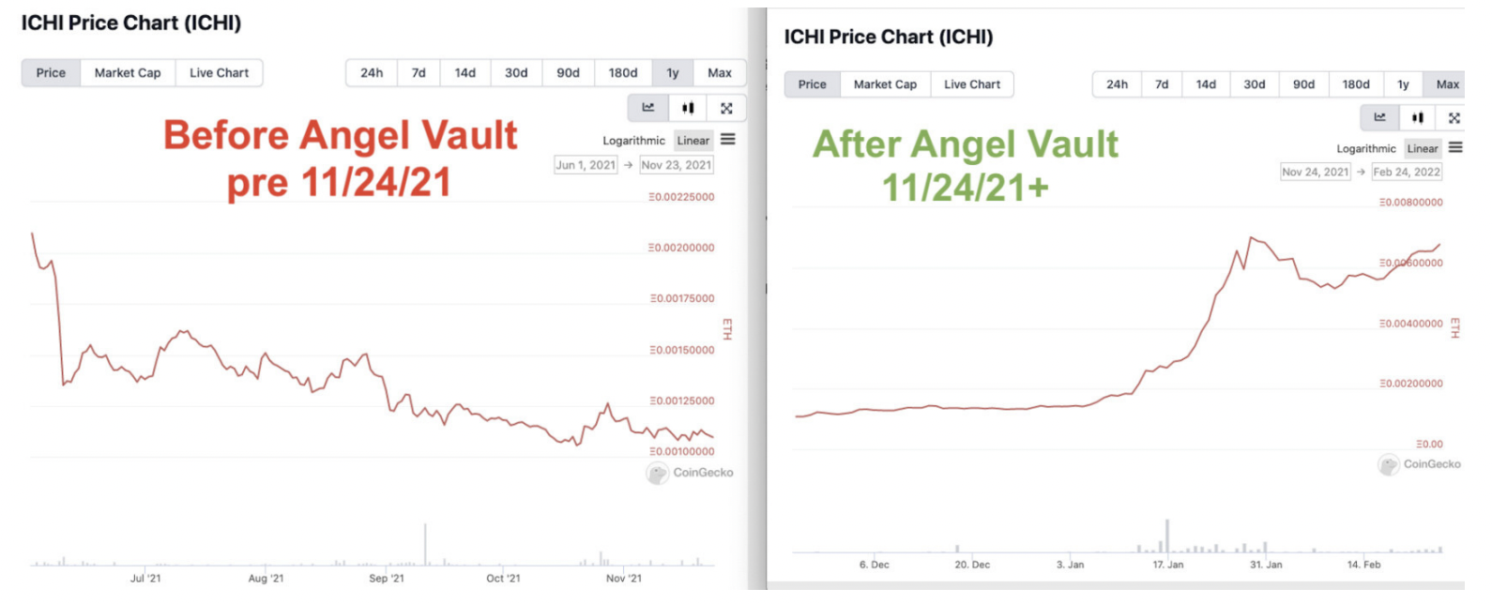

Risks:

1) pool parameters config.* - collateral factors assigned to assets, as volatile assets should normally have more restricted LTV ratios.

2) bad oracle (oracles to manage liquidations and keep the protocol or pool afloat)

3) little liquidity - if we supply too little GIV we can manipulate the price of the asset to return to large supply position with a huge collateral and use that to borrow funds without intention of returning.

Solution:

1) Fuse liquidates unhealthy loans where the value of the collateral falls below the borrow limit.

During a liquidation process, a borrower’s deposit will be sold (i.e. liquidated) to repay the loan and bring the LTV to a safer value.

2) We have a lot of GIV, we can sell them the idea that we plan to heavily over collateralize it and maintain a borrow rate of 30% or lower. Price of GIV goes down we can deposit more GIV to make sure that we can sustain at least 70% sudden drop in price.

Maintain a utilization rate of 80% = ~800k $GIV

(prevent bank runs where the high utilization rate of the pool prevents users who have deposited the assets from exiting them as there is insufficient liquidity).

3) Rari Safety Scores are displayed on the pool discovery page to help provide a metric for comparison between pools,

Fuse explained: <https://medium.com/rari-capital/fuse-explained-3ef2e0747953>

Guide to rari capital: <https://medium.com/stakingbits/guide-to-rari-capital-fuse-permissionless-money-markets-2632a2a72929>

Plugins? help with the stream connection?

1) Staking plugin: The staking plugin will utilize idle tokens by staking them for rewards through their native platforms

2) Interest Rate Model Plugin: the lending interest rate for assets will match the staking rewards yield available on that asset.

Config*:

Assets (as long as an oracle supports it)

Oracles

Platform fee

Admin Fee (additional fee on top of protocol fee)

Liquidation Incentive (additional collateral given to liquidators as an incentive to perform liquidations of underwater accounts)

Whitelist (option for the pool to be permissioned for selected addresses)

Close Factor (factor of a liquidatable account’s borrow that can be repaid in a single liquidate transaction)

Upgradeability (whether the pool parameters can be modified)

Collateral Factor (represents the proportionate increase in borrow limit an account receives)

Reserve Factor (portion of borrower interest that is converted into reserves)

Pool Admin (an Ethereum address, multi-sig or DAO contract that owns and manages the pool)